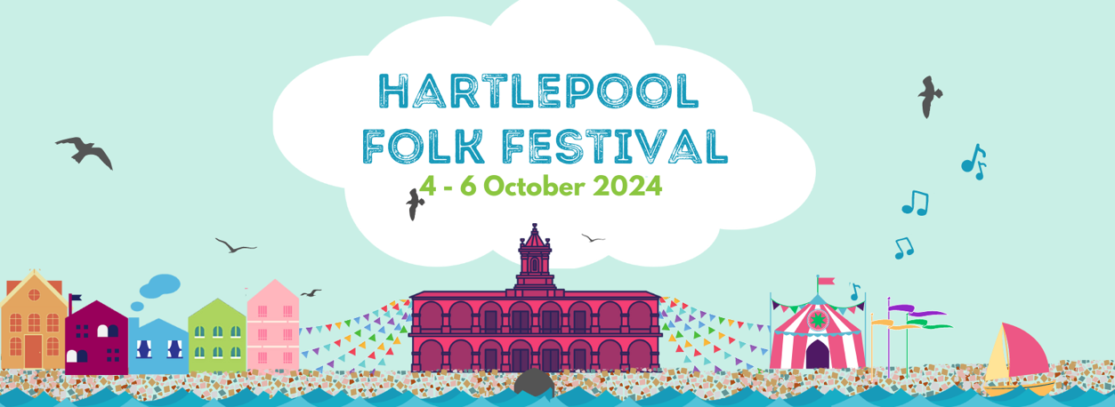

Joining Instructions and additional information
We're so pleased that you're joining us for Hartlepool Folk Festival!
The festival is based on the historic Hartlepool Headland, which means all venues are within a few minutes’ walk of each other. In addition, the venue-based events will take place surrounding our free outdoor family festival, which makes for a brilliant atmosphere. The Headland is the loveliest part of the town, with around 1500 years of incredible history, so please explore spots like the Town Moor, the Lighthouse, the medieval Town Wall and Sandwell Gate, the Fish Sands and the Heugh Battery Museum. And do try some of our cosy, welcoming pubs!

If you haven’t yet, have a look at the weekend timetable at ﻿https://www.hartlepoolfolkfest.co.uk/whatsonwhen where you can start to plan your weekend.
Below you'll find some useful information about wristbands, tickets, camping and venues. We can’t wait to see you in Hartlepool!

BOX OFFICE OPENS AT 9:30am ON FRIDAY, 6 October.

Box Office is located in the foyer of the Borough Hall, Middlegate, Hartlepool TS24 0JD. Exchange your ticket receipt for wristbands or event tickets here. If you have purchased advance tickets for individual events, you MUST exchange your receipt for an event ticket at the Box Office.

Tickets will be available from Box Office for many individual events throughout the weekend.

Event Admissions Policy
Doors open approximately 30 minutes before events start. Day and weekend tickets grant, but do not guarantee, admission to any festival event. The exception is mainstage events at the Borough Hall, where all ticketholders can be comfortably accommodated.

For events where individual tickets have been pre-sold, event ticket-holders will be asked to queue separately, and when doors open (up to 30 minutes before the show) they will be admitted to the venue at the same time as Day and Weekend ticket-holders. This is to ensure that everyone holding an advance event ticket may be accommodated. If you have an event ticket, we cannot hold seats for you after the show start time; please allow yourself plenty of time to arrive and be at the venue at least 15 minutes before the start time (though we recommend half an hour)
Individual events: Please check venues and individual event start times against the Festival Programme on the Website, and against any programme change notifications at Box Office. Occasionally changes do occur in the programming process, and we apologise for any inconvenience caused.

Campsite
Our new is at Central Park, Ropery Rd, Hartlepool TS24 0BE. If you’ve booked a caravan or camping spot, you will receive a wristband which allows access to the campsite along with your festival wristband. Staff will take note of your vehicle reg and contact details. The campsite is open from 2pm on Thursday until midday on Monday. Thursday arrivals: Campsite stewards will have a list of booked campers to allow you access, but the Box Office will not be open until 9:30 Friday, which is when you will be able to collect your wristbands.
On site there are portaloos (including a disabled loo), a non-potable water point, and a sanitation point for the disposal of waste. Showers are available at the Headland Sports Centre from 9am – 3pm daily for £1.50. The festival shuttle drops off a few minutes’ walk from the Sports Centre, which is next to the Borough Hall.
Please note: Please use a torch/your phone when moving about the site in the dark. The field is pretty level and is not used for agriculture, but all fields have the odd lump and bump.
Fire Points will be signposted. Please practice good caravanning fire safety and keep your own fire bucket near the entrance of your vehicle. There is overnight security in the campsite area, but please practice sensible security measures in your vehicle or tent.
Please follow the instructions of the caravan site managers to your pitch. These have been laid out in accordance with the directions of our fire safety consultant and allocated distance between vehicles must be observed. If you have mobility requirements and would prefer hardstanding to grass, there is limited space at the top of the site available on a first-come, first-served basis.

Parking and Getting Around
There is substantial free street parking on the Headland, as well as in the area surrounding the Borough Hall.
The Festival is operating a free bus service to take visitors to and from the site. Bus times are as follows:
The bus will pick up from the front of the Premier Inn, the front of the Travelodge, The Grand Hotel, the campsite, and stop immediately outside the Borough Hall. The full journey time is approximately 10 minutes.
Times for the shuttle are as follows:
Friday
12pm – 3pm, 4pm - 8pm, 10pm - 1am

Saturday
9am - 12pm, 5pm - 8pm, 11pm - 1am

Sunday
9am - 12pm, 5pm - 8pm, 10pm - 11pm
If you wish to go back and forth outside of the shuttle times, the Stagecoach Number 7 bus operates regularly (every 10 – 15 minutes) throughout the day and until 11pm, stopping outside ADSA, outside the campsite on Westview Rd (Throston Engine House stop), and directly outside the Borough Hall. The timetable is available here: www.stagecoachbus.com/routes/north-east/7/middlegate-owton-manor/xmbo007.o

Accessibility
We have still not been able to source a fully wheelchair-accessible shuttle coach with the capacity we require; however, the Stagecoach No7 bus is fully accessible and travels the same route as the shuttle. If you are a disabled visitor who has needs that are not served by these arrangements, please let us know your requirements in advance so that we can do our best to make alternative arrangements for you.
All venues are completely accessible.
If you are disabled and require a free carer’s/companion’s ticket, please let us know in advance and it will be waiting at Box Office.
Food and Drink
There will be numerous hot food options located outdoors, as well as coffee stands, from midday on Friday. Our Craft Market is located in the Headland Sports Hall on Union Street, around the corner from the Borough Hall (you can reach it internally through the mainstage hall as well, but only when the venue is open for concerts). You’ll find a spacious area where you can sit, relax, have your meal or maybe a nice bit of cake, and take a breather – and maybe even shop for something special from our carefully selected stallholders. The Craft Market is open from 10am – 6pm daily.
In the Borough Hall, Three Brothers Brewery will provide our concert real ale bar. Look out for Bold Miners, our festival beer!
The Headland has some great pubs. The Fisherman’s Arms is brilliant for real ales and a warm welcome. It is a festival venue, and is holding a beer festival over the weekend. The Pot House is also a festival venue and will be hosting late night music and song sessions.
That should be all the info you need prior to arrival, but if you have any questions, don’t hesitate to contact us. We hope you have a fantastic festival.
Joan and the Festival Team

